ITT-216- Port Security Configuration

Professor: Tim Collins
Course: ITT-216 Enterprise Route & Switch
Student: Liela Pressley
Date: 4/11/2023
Title: Port Security Configuration
___________________________________________________________________________________
Successfully added mac-addresss sticky to switch 2 for admin vlan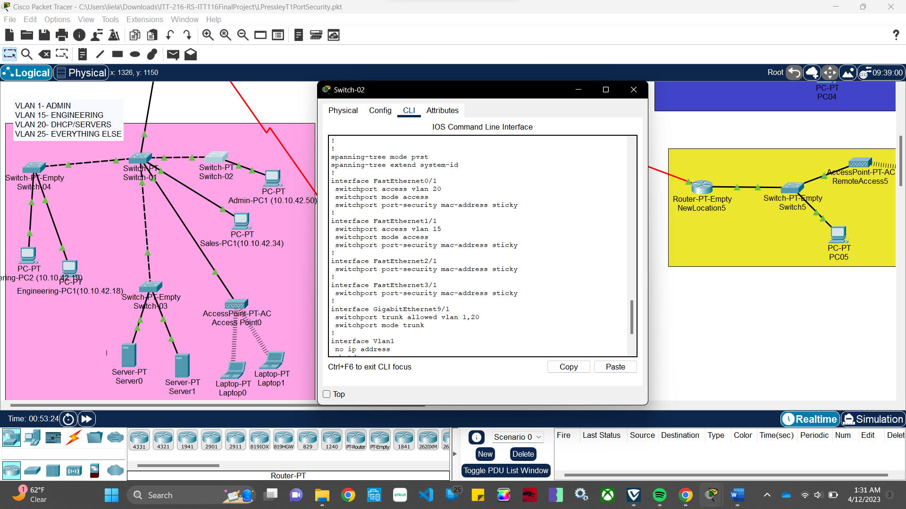
Successfully added mac-address sticky and restriction to accesspoint from switch 1 on vlan 25
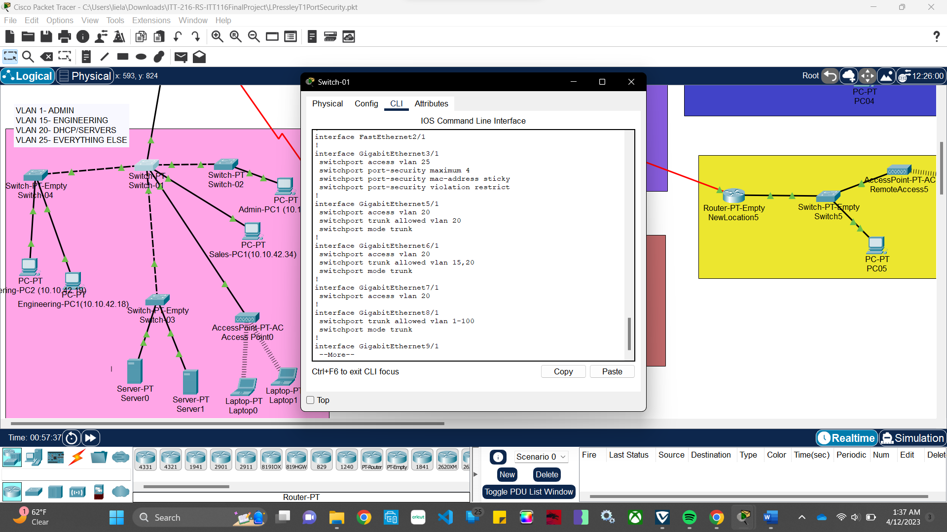

Successfully pinging default gateway on servers from admin PC
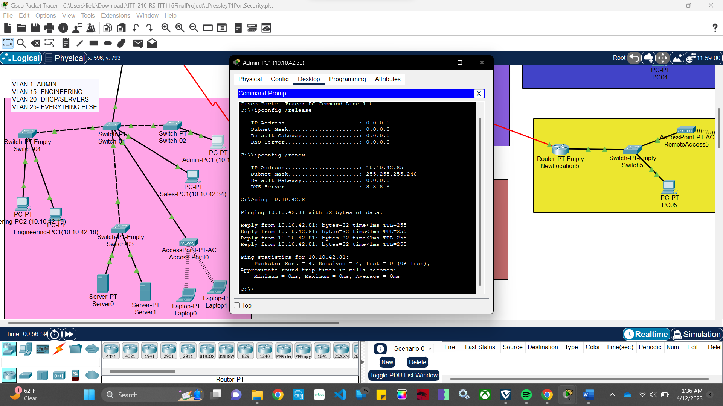

Laptop successfully ping default gateway
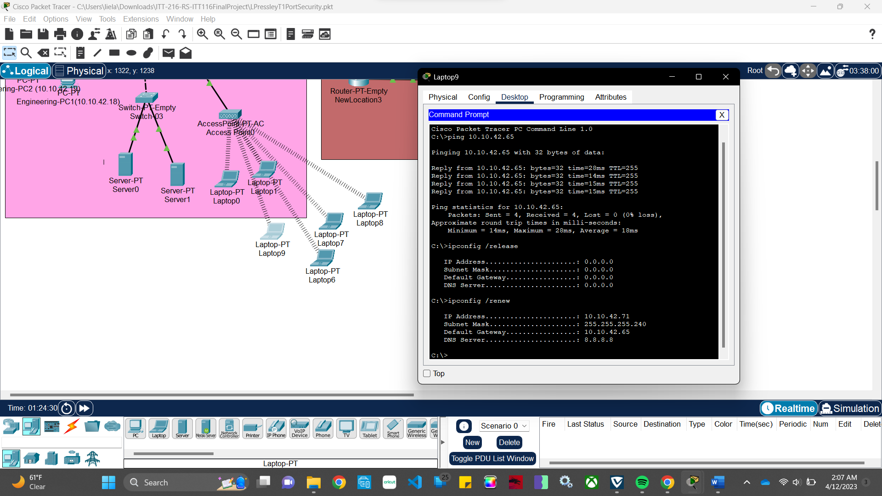
Successfully ping DHCP Server from newly added laptop
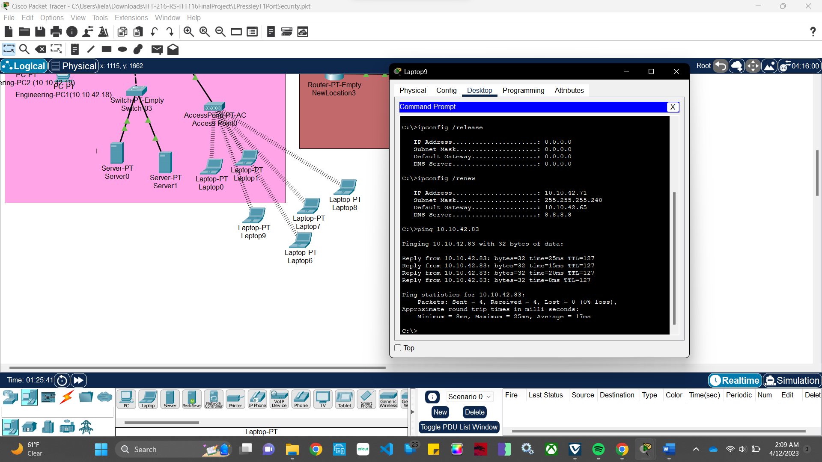
Successfully pinging laptop6 from laptop9.

Successfully pinging DHCP server from all laptops
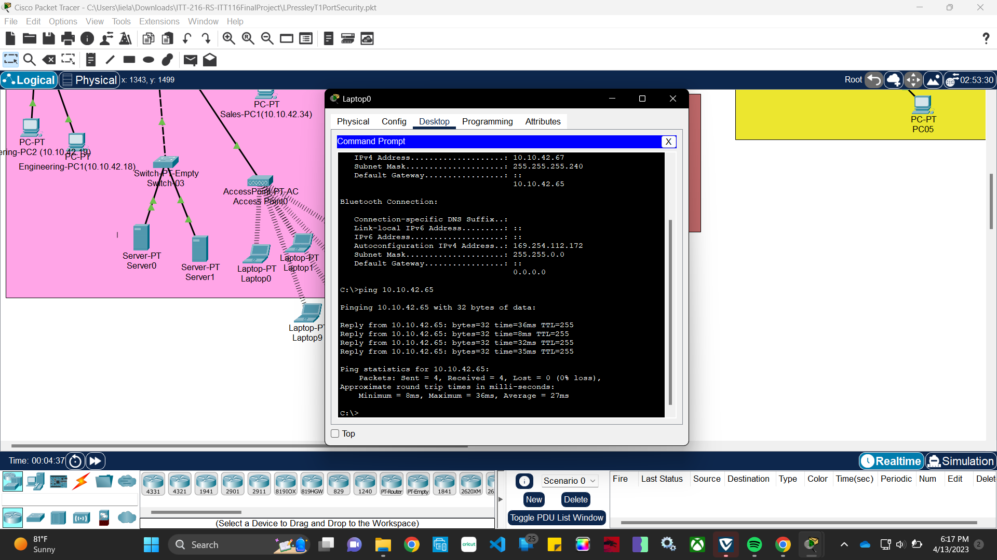
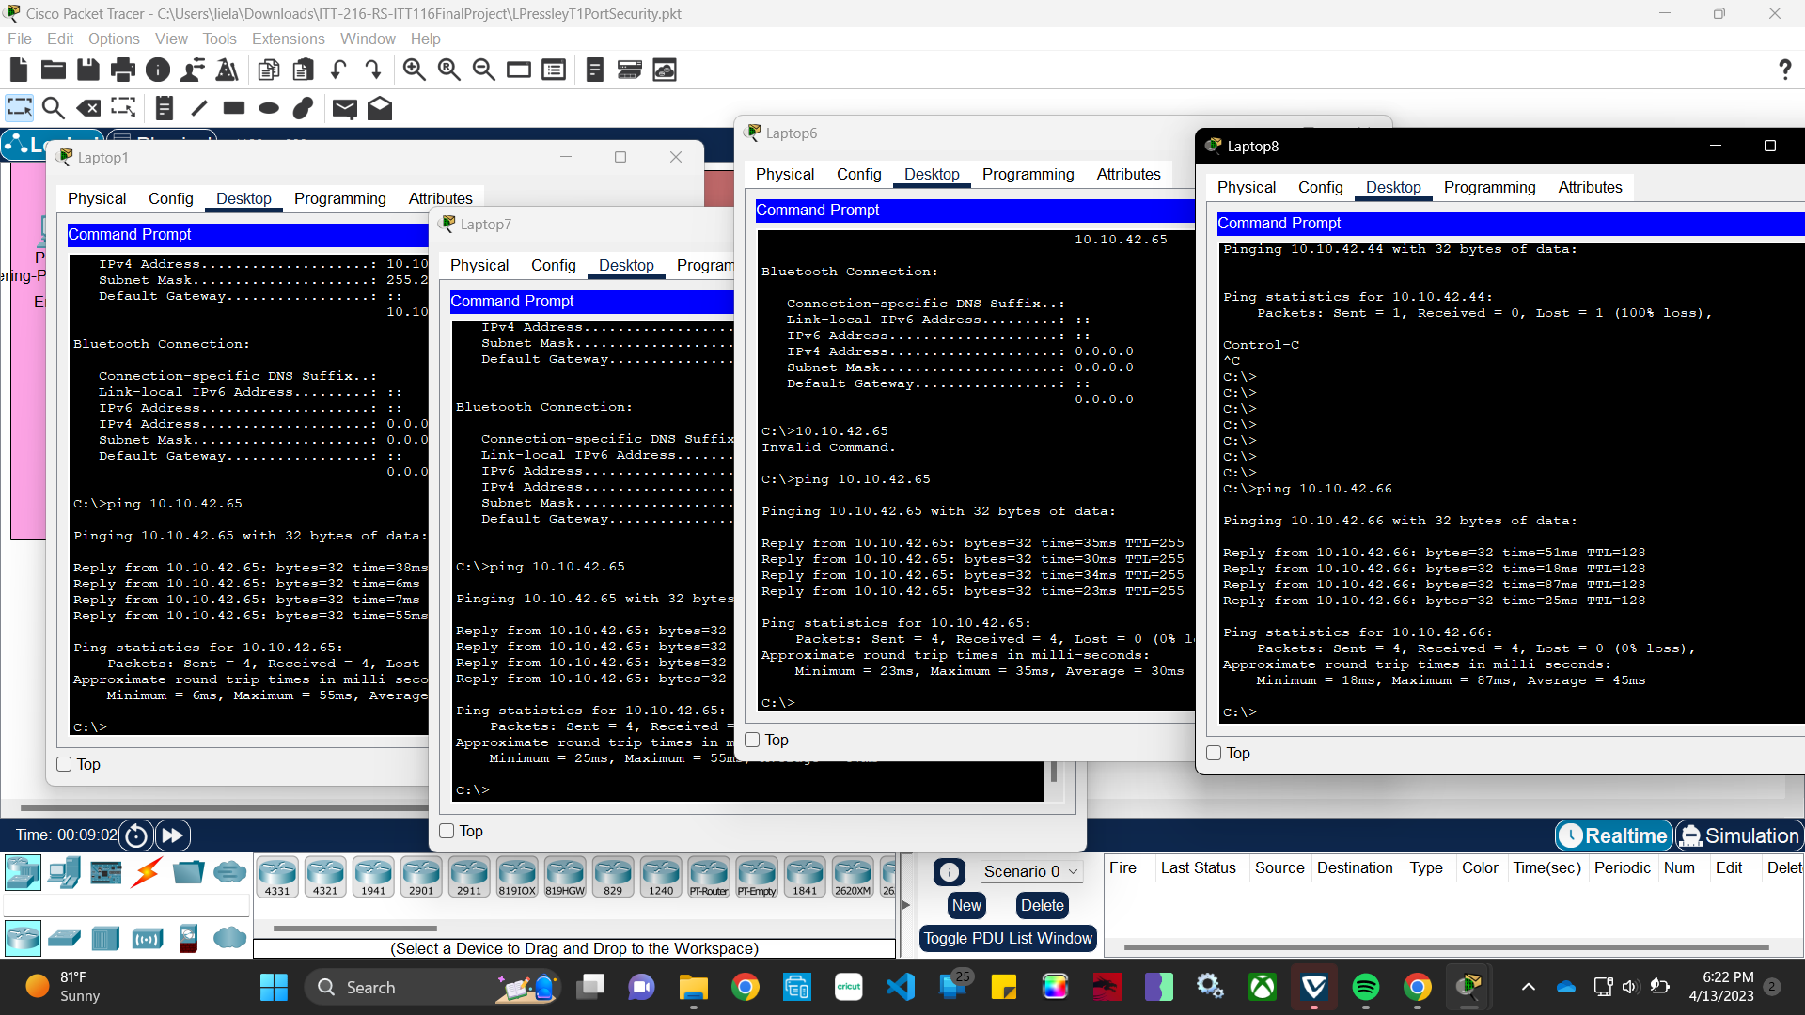

Adjusted switch-01 G3/1 port to allow port-security and to keep track of MAC-addresse after the pinging.
